Case 6-AFR-Mali-Dogon-Reliquary-Male Capped Figure-Bronze-19th c

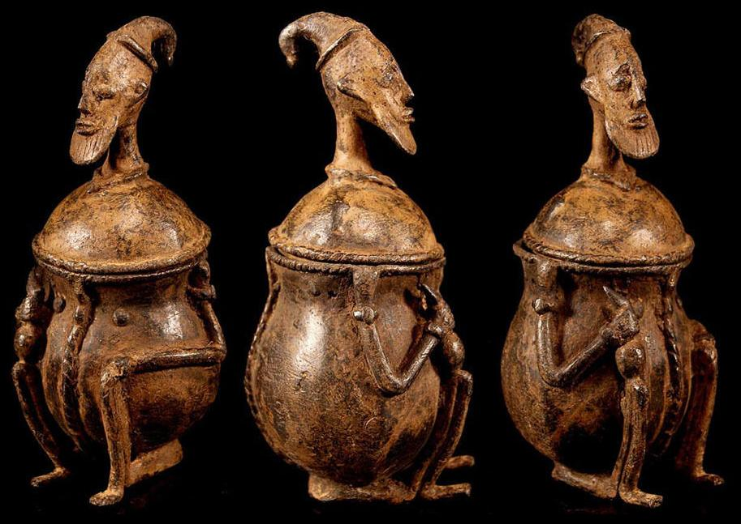
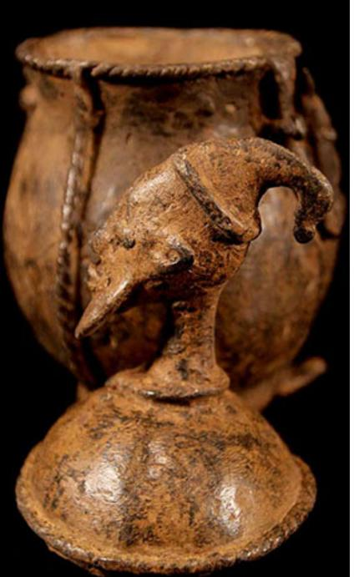
AFR-Mali-Dogon-Reliquary-Male Capped Figure-Bronze-19th c
Case No.: 6
Accession Number:
Formal Label: AFR-Mali-Dogon-Reliquary-Male Capped Figure-Bronze-19th c
Display Description:
Used for probably storing betel nut juice or some other stimulant. Its lid has a provocative likeness of an elder who holds the baton de commandement of his office in his right hand. He was probably an important figure of his tribal group on Mali’s bandiagara escarpment.
LC Classification:
Date or Time Horizon:
Geographical Area:
Map:
GPS Coordinates:
Cultural Affiliation:
Medium: Bronze
Dimensions: H 7 inch
Weight:
Provenance: Rarity finest old Dogon bronze Figure
Condition: fine old patina
Discussion:
References

Order details
Printer friendly page

Sales order
Sold by collector-girl77... ( 472 )
+ Show additional actions

Delivery package 1 of 1
Estimated delivery Monday, Jun 6, 2016 - Monday, Jun 13, 2016
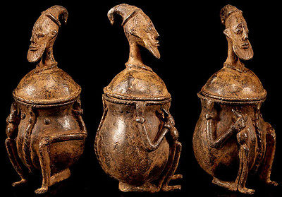

Rarity finest old Dogon bronze Figure - Container Mali
Item price | $175.00
Quantity | 1
Item number | 262450537063
Shipping service | Standard Shipping
Contact seller
Return item

Shipping address
Ralph J Coffman Jr
149 Atlantic Ave
Swampscott MA 01907-2427
United States

Order total

Subtotal | $175.00
Shipping | $28.00
Total
$203.00
View PayPal transaction

Order placed on
Wednesday, May 25, 2016
Payment method
PayPal
Payment date
Wednesday, May 25, 2016

